Digital Logic Design ECE3441– 2025FA
Lab 4: : Full-Adder Subtractor Calculator
Names: Anaya Scott and Carol Morales

Overview: Goals of the Lab

In this lab, we are tasked to focus on the design and Boolean fundamental of a Full Adder. In part 1, we figured out how to use discrete logic gates while proving the method with Kmaps and truth tables. And then we build a8 bit macro full adder with the intent to understand the schematic layout and scalability of the design. Lastly, we enhanced the logic design to combine the ability to add and subtract by placing XOR gates to perform at 2’s complement. This lab will allow us to understand the main functions of the ALU in a practical sense.
Step-by-Step Procedures and Results
Copy the truth table for the full adder (Cout and Sum) into your lab document. 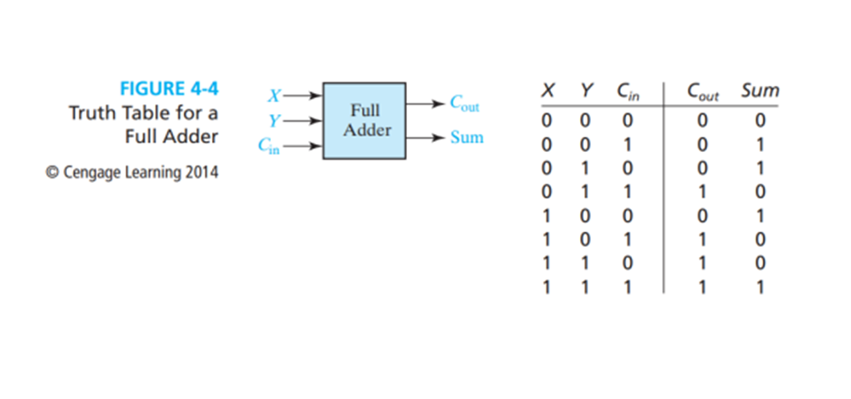
2. What does Sum mean in the context of binary addition?
The sum is known to be the least significant bit from the result of the current column being added. Like A+ B + Cin.
3. What does Cout mean in the context of binary addition?
It means the carry out which is the value of 0 to 1, that is generated for the next bit position when the sum of a current bit is equal to 2 or 3.
4. Provide the simplified sum-of-products formulas for Sum and Cout. Show your Kmaps.

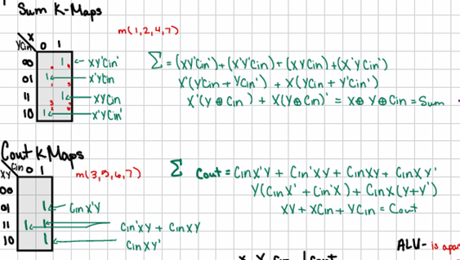
Figure 1: Is the work for question 4.

5. Provide the simplified product-of-sums formulas for Sum and Cout. Show your K

maps.

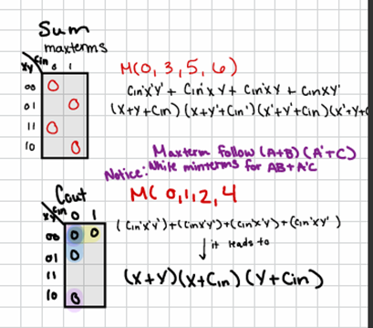

Figure 2: The work for Question 5.

6. How many minterms and maxterms do the Cout and Sum formulas each contain?

There are 4 minterms and 4 maxterms for both Sum and Cout

7. Build the Cout and Sum circuits in one simulation file. Provide a screenshot of your

schematics and the timing diagram for all combinations of A, B, and C. Label your

inputs and outputs as necessary to label the waveforms on the timing diagram.

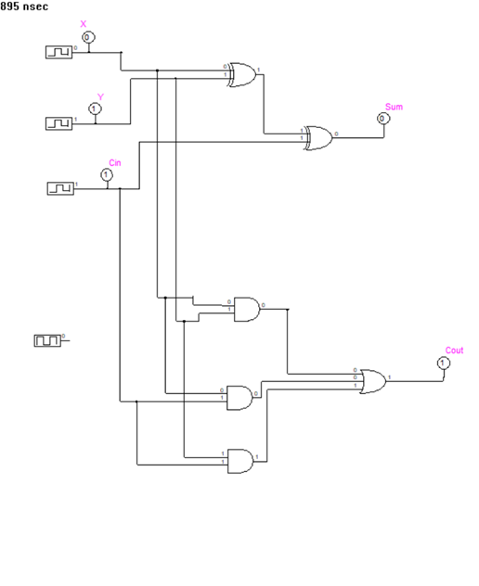
Figure 3: The schematics for the Function.
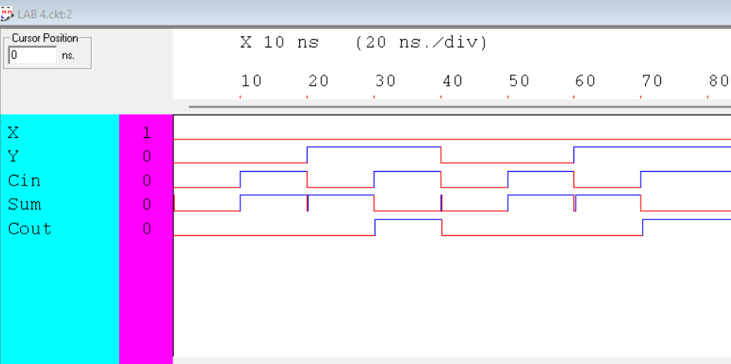
Figure 4: The time diagram the schematics.

8. Research what an “ALU” is. What does it have to do with the full adder?

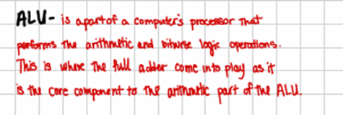

Figure 5: ALU definition

9. Build the 8-bit adder described above using full adder macros.

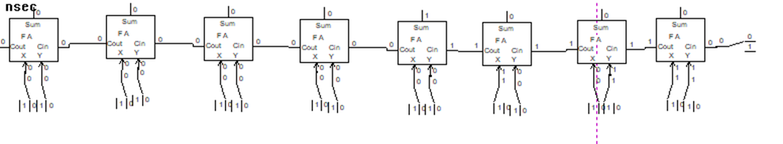
Figure 6: The Full Adder Macro Schematics.
10. What are the major differences between your Part 1 build and the full adder macro? Why might you choose to use one over the other?
a In part 1 we used logic gates like XOR and AND to create a full adder, while in Part 2 we used macro components to build the full adder at an advance level allowing us to add or subtract at 8 bits.
11. What is the difference between unsigned overflow and signed overflow?
a Unsigned overflow is when a carry out is present. Making the result to be too large to be given a number, making it unsigned.
b Signed Overflow is when 2 positive numbers give a negative answer or 2 negative numbers give a positive answer, making the carry in different from the carry out
12. Give four examples of 𝐴 +𝐵, where A and B can be two’s complement positive or

negative values. Include screenshots of your SimUAid / LTspice / online build doing these

examples in your report. Caption your figures to indicate what numbers are being added

and what the result is.


Figure 7:Binary math of 20+30=50.
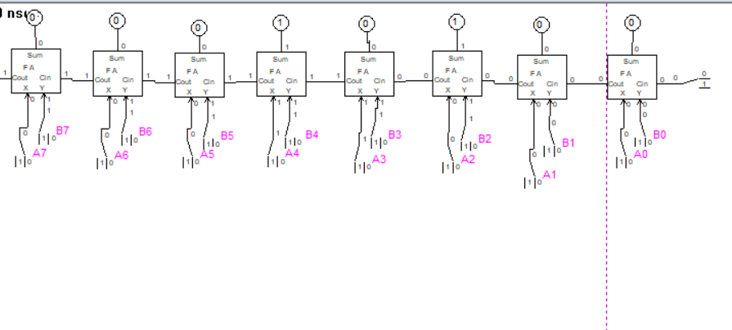
Figure 8: Binary Math of 24 + -4 = 20.
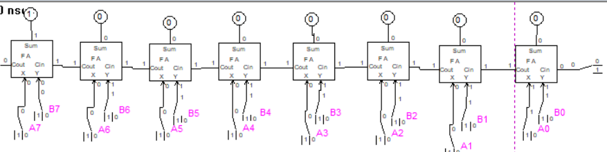
Figure 9: Binary Math of 127 + 1 = 128. This math equation shows signed overflow.
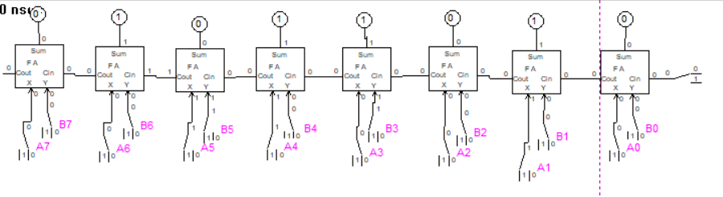
Figure 10: Binary Math of 50+40=90.
- In your own words, explain the benefit of adding the XOR gate into your Part 2 circuit build.
  - Adding in the XOR gates allowed the circuit to do both addition and subtraction.
- What are the limits of your adder-subtractor calculator? With 8 bits, what are the largest and smallest permissible two’s complement numbers that it can handle before undergoing signed overflow?
  - The range of the calculator is from 127 to -128. The signed overflow will happen if the sum of all outputs in the calculator falls outside of the range.
- Give four examples of 𝐴−𝐵, where A and B can be two’s complement positive or negative values. Include screenshots of your SimUAid / LTspice / online build doing these examples in your report. Caption your figures to indicate what numbers are being added and what the result is.

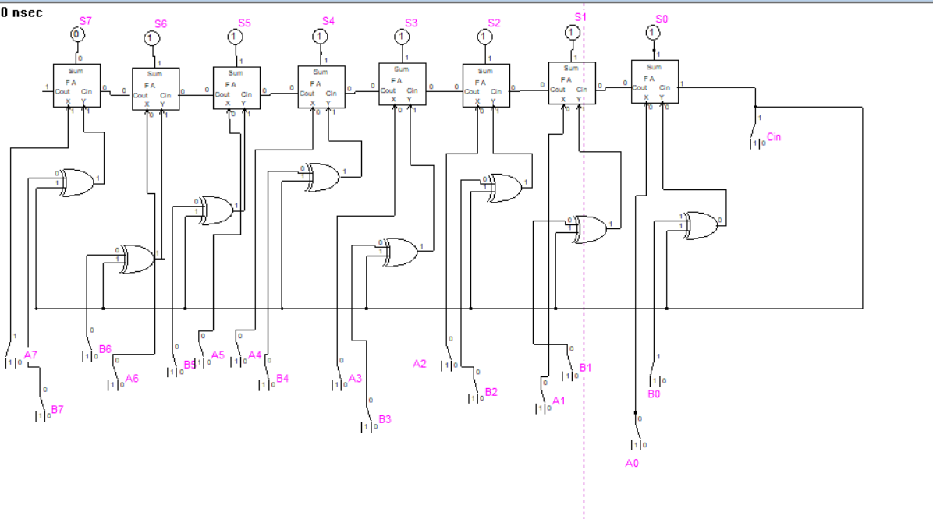
Figure 11: Subtractor math: 1-128=-127.
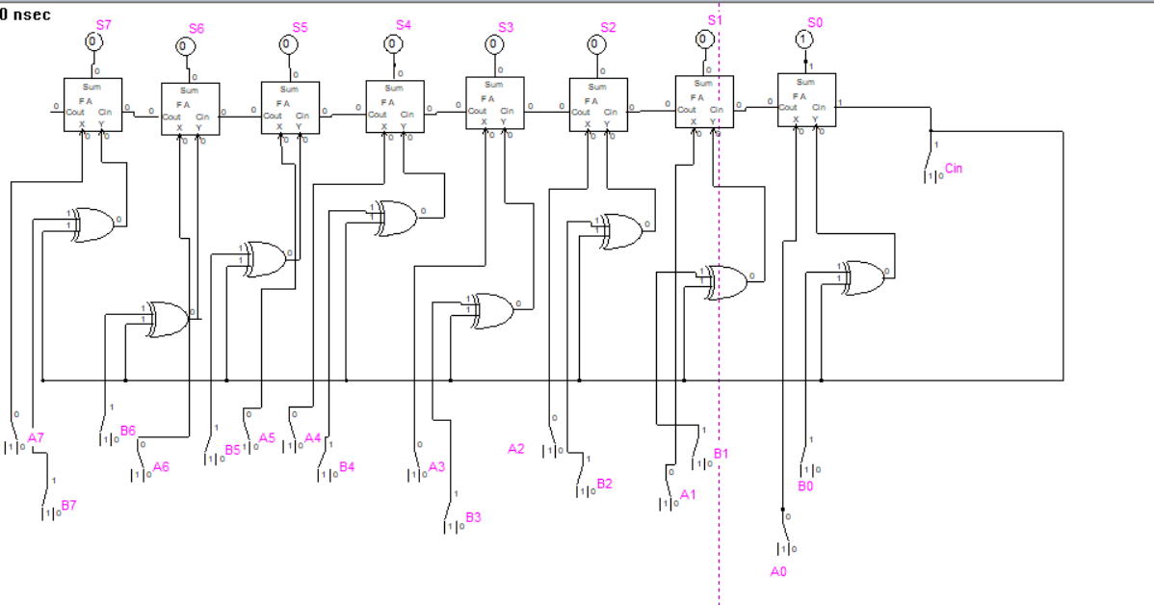
Figure 12: Subtractor Math: 0-1=-1.
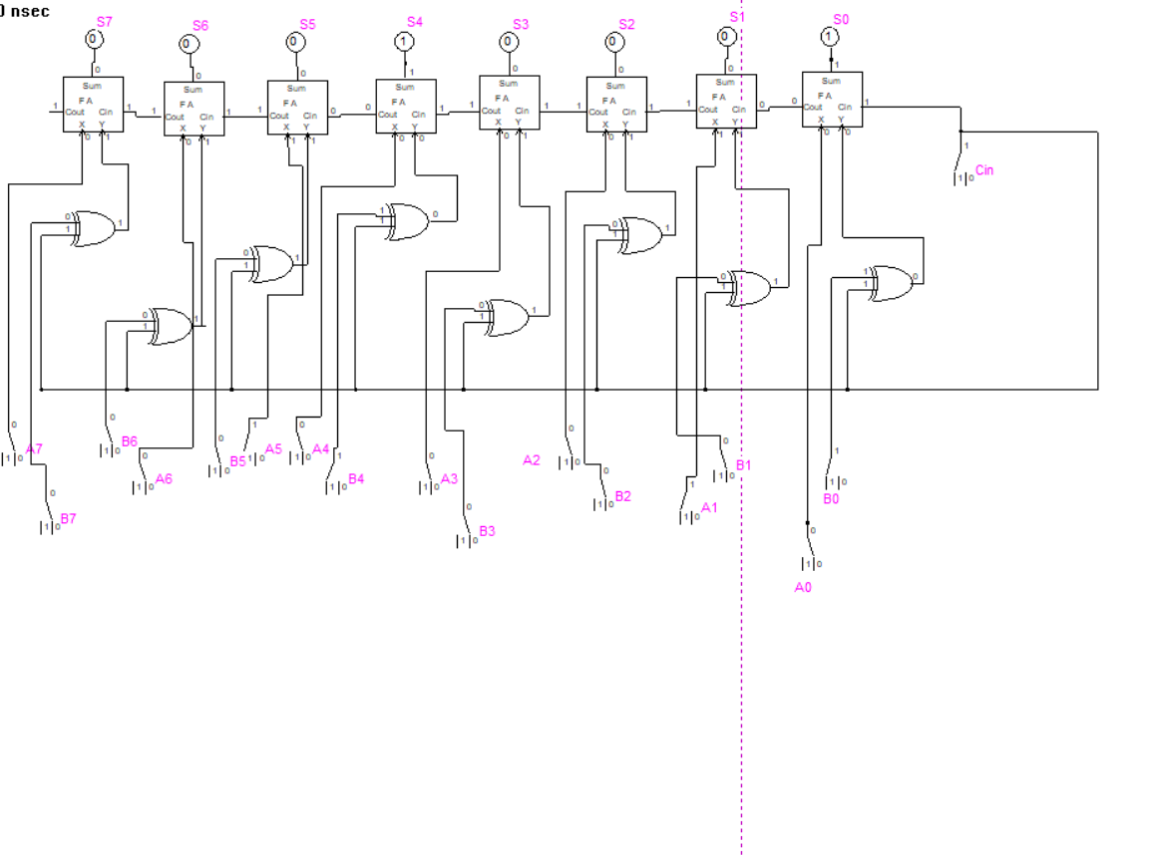
Figure 13: Subtractor Math: 34-17=17.
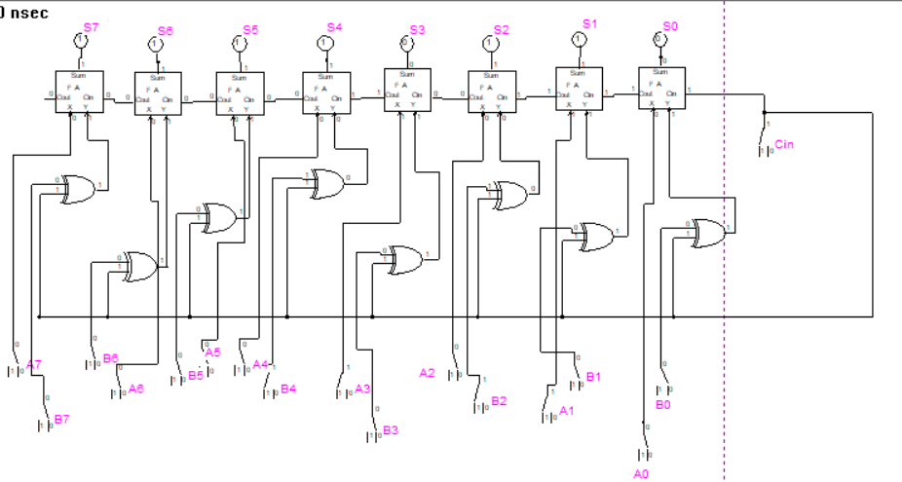
Figure 14: Subtractor Math: 10-20=-10.

Conclusion

In this Lab, we use the methods of the Full Adder method to create a binary calculator. We demonstrated the use of K maps and Boolean math to prove the theory of the calculator functions. Then we later use the Full adder part component to show the functionality of the calculator, with no ANDs or XOR gates. In the second part we then add in the XOR gates to all the calculator to do both adding and subtracting. Within this lab we learned the functions of the full adder on a more detailed level as well as understanding the mechanism of the full adder in macros.

